DevOps Final Project

deployment.yml
apiVersion: apps/v1 kind: Deployment metadata:
name: my-deploy namespace: my-bank labels:
name: my-deploy spec:
replicas: 1 selector:
matchLabels:
apptype: web-backend strategy:
type: RollingUpdate template:
metadata: labels:
apptype: web-backend spec:
containers:
- name: my-web
image: 22csl258/mysimplewebapplication:tagname ports:
- containerPort: 9001

---

apiVersion: v1 kind: Service metadata:
name: my-service namespace: my-bank labels:
app: my-service spec:
type: NodePort ports:
- port: 9001
targetPort: 8080

nodePort: 30007 selector:
apptype: web-backend

Minikube
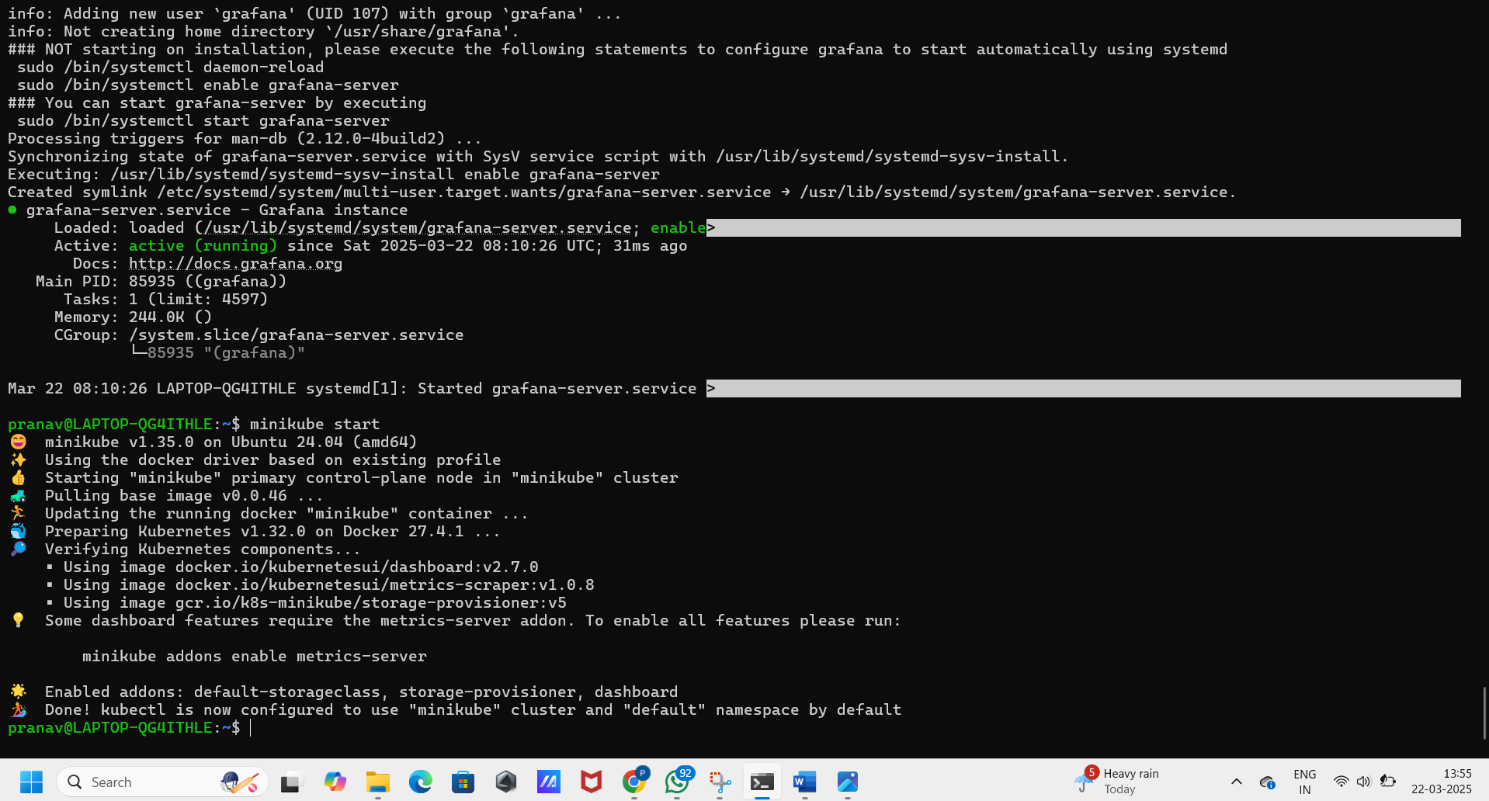

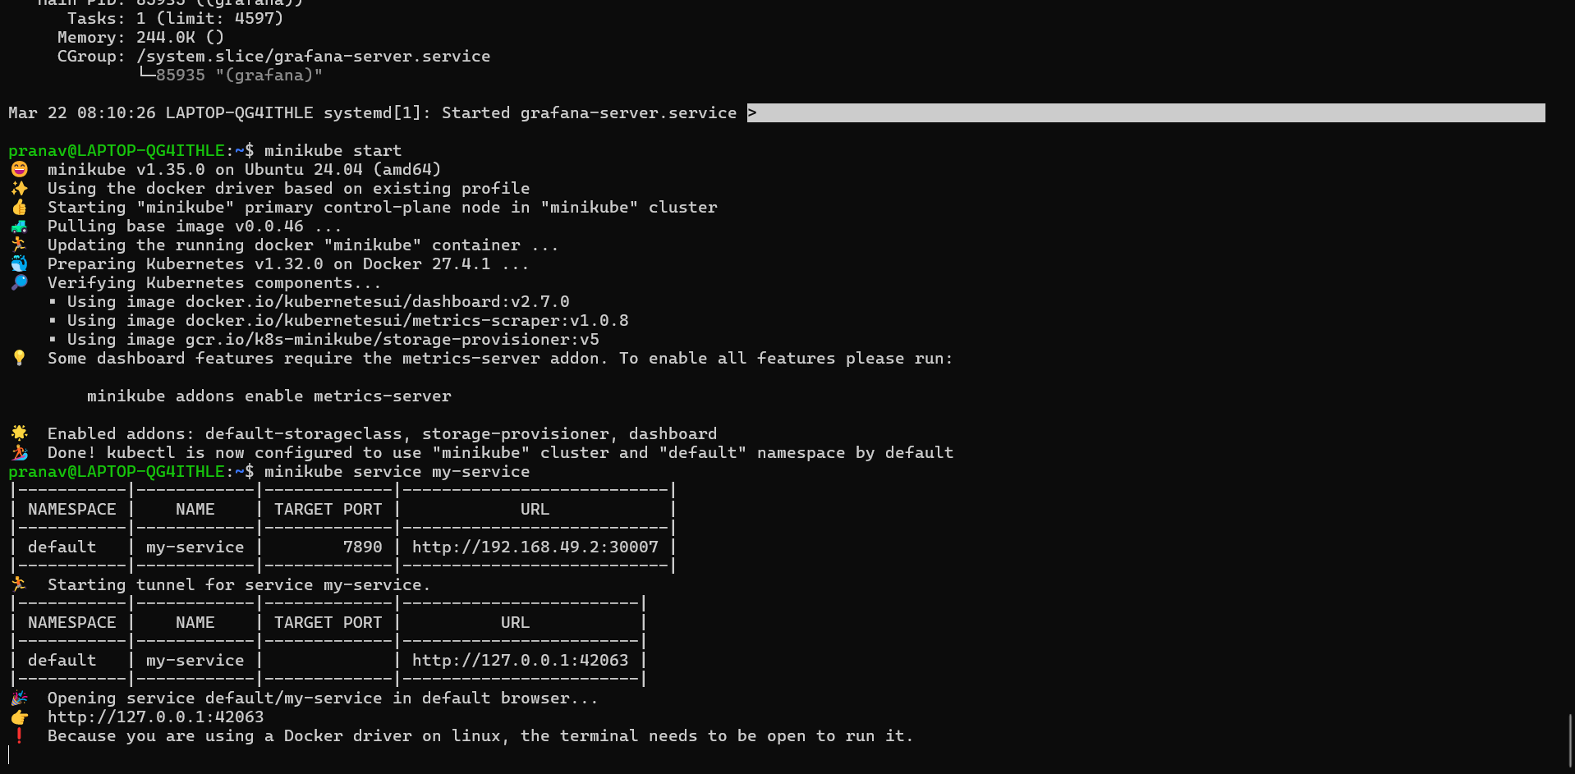

Pipeline script – jenkins JAVA Application pipeline {
agent any

stages { stag ('scm') {
steps {
git branch: ''
}
}
stage('builb-clean') { steps {
sh "mvn clean"
}
}
stage('build-validate') { steps {
sh "mvn validate"
}
}
stage('build-com') { steps {
sh "mvn compile"
}
}

stage('build-test') { steps {
sh "mvn test"
}
}
stage('build-install') { steps {
sh "mvn package"
}
}
stage('build to images') { steps {
script{
sh 'docker build -t .'
}
}
}
stage('push to hub') { steps {
script{
withDockerRegistry(credentialsId: 'Docker_cred', url: 'https://index.docker.io/v1/') { sh 'docker push '
}
}
}

}
stage('Deploy App') { steps {
withKubeConfig(caCertificate: '', clusterName: 'minikube', contextName: 'minikube',
credentialsId: 'mukubeconfig_011', namespace: '', restrictKubeConfigAccess: false, serverUrl: 'https://192.168.49.2:8443') {
sh 'kubectl apply -f deployment.yml --validate=false'
}
}
}
stage('Test') { steps {
withKubeConfig(caCertificate: '', clusterName: 'minikube', contextName: 'minikube', credentialsId: 'mukubeconfig_011', namespace: '', restrictKubeConfigAccess: false, serverUrl: 'https://192.168.49.2:8443') {

sh 'minikube service my-service --url | xargs curl'
}
}
}
}
}

